Tiny cute adorable fluffy baby raccoon with knitted blue scarf leaning at a table in a medieval pub holding a coffee cup, anthropomorphic, Jean-Baptiste Monge, soft cinematic lighting, 8k, intricate details, portrait, Pixar style character, old fashioned movie style

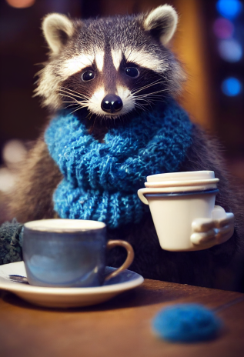

A cute and adorable baby fox with big brown eyes, autumn leaves in the background enchanting,immortal,fluffy, shiny mane,Petals,fairyism,unreal engine 5 and Octane Render,highly detailed, photorealistic, cinematic, natural colors

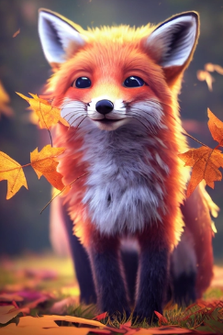

a cute fluffy chubby marmot sunbathing on a pile of rocks, snow mountains background, turquoise glacier lake afar, clear blue sky, highly detailed, golden hour, natural light, octane render, unreal engine

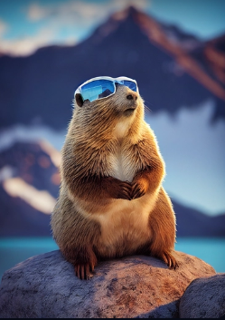

cute little creature, realistic, photographic

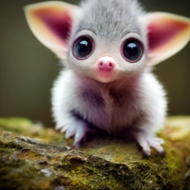

A cute and adorable baby white fox with a big fluffy tail,holding a pink flower lay on a cloud in paradise,big eyes,Peach blossom,stream,enchanting,immortal,fluffy,shiny mane,Petals,fairyism,unreal engine 5 and Octane Render

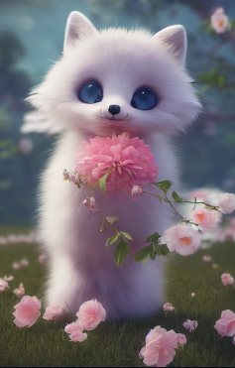

Cute handsome snow leopard Sparkly. Ice Themed. Sakura Flowers. Stage lighting, epic, 8k, highly detailed

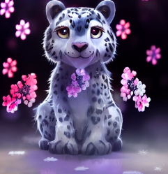

Tiny cute and adorable baby fox, symmetrical ears and eyes, jean-baptiste monge, anthropomorphic, Delight winter and snow backgrounds, elegant shapes, magical dreamy lighting, wallpaper, photorealistic, Rembrandt light, fantasy, detailed, symbolic, high detailed, 3d render, 8k

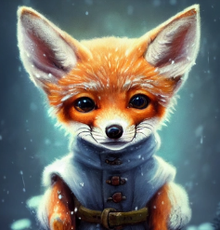

Tiny cute adorable fluffy white cat with knitted blue scarf leaning at a table in a medieval pub holding a coffee cup, anthropomorphic, Jean-Baptiste Monge, soft cinematic lighting, 8k, intricate details, portrait, Pixar style character, old fashioned movie style

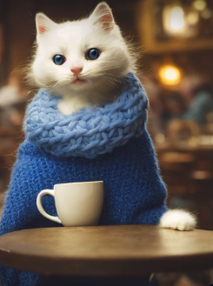

Tiny cute adorable fluffy baby pig with knitted blue scarf leaning at a table in a medieval pub holding a coffee cup, anthropomorphic, Jean-Baptiste Monge, Delight winter and snow backgrounds, soft cinematic lighting, 8k, intricate details, portrait, Pixar style character, old fashioned movie style,photorealistic, Rembrandt light, fantasy, detailed, symbolic, high detailed, 3d render, 8k

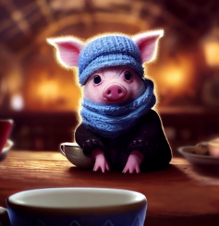

Tiny cute adorable fluffy black cat with knitted green scarf leaning at a table in a medieval pub holding a coffee cup, anthropomorphic, Jean-Baptiste Monge, soft cinematic lighting, ultra realistic, 8k, intricate details, portrait, Pixar style character, old fashioned movie style

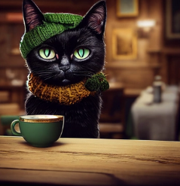

super cute red dragon baby, precision, photorealistic, cinematic, realistic

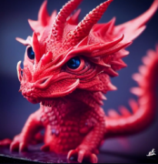

portrait of a dragon warrior, glowing eyes, photorealistic, smoke billowing out from mouth, sparks across screen, volumetric lighting

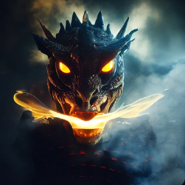

<<https://s.mj.run/kMQQ7jAZaL4>> Adorable baby chrome cyberpunk cat , Dreamworks, Character design, soft cinematic lighting, intricate details, portrait, Pixar style character

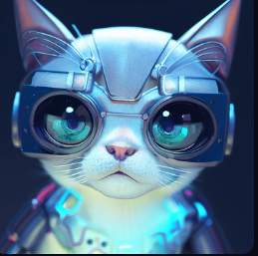

32k, 16k, 8k, hyper sharp focus, octane render, hdr, stunning intricate detail, photo realistic, realistic CGI, bright studio lighting, hyper detail, pixar style, cartoon style, Pixar style Dumbo octopus as Naavi from Avatar, bioluminescent detailed dots texture, Happy Accident, large drooping translucent skin webs, detailed bubbles and reef aquatic plants maximum texture, enormous hyper detailed glowing eyes, hyper detailed triple iris, happy, 25mm shot, portrait, full frame shot, cinematic action

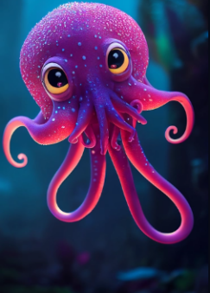

character design, Pixar style, cute and adorable mallard, golden ratio, full body, dramatic lighting, cinematic, portrait, fine details,

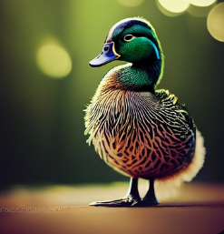

frog monkey portrait

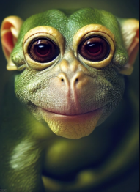

ultra cute and adorable brave little capybara, pixar style, anthropomorphic, dramatic lighting, octane render, 8k, portrait, hyper realistic, prized photography, close-up, depth of field

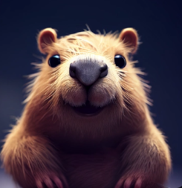

cute baby snowy owlet portrait, photo studio, pixar style, octane render, photo realistic

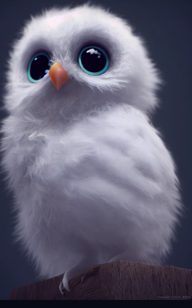

The photo-level real and cute little rabbit Hanfu, the ancient town of China, the prospect is a osmanthus, drinking tea on the table at night, background is full moon, managing, drama light, super realistic, managing, drama light,character portrait by senior character artist, cgsociety, fantasy art, playstation 5 screenshot, 2d game art,featured on cgsociety, rendered in unreal engine, artstation hd, rendered in maya ，8k,hd

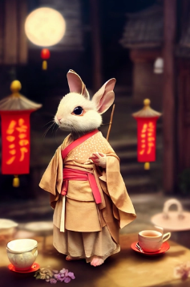

double exposure of full portrait of a stunning dragon, amethyst scales, chilling stare and big horns finely detailed, surrounded by magic, flames, fire, burning forest, cinematic lighting, 4k, 8k, unreal engine 5, octane render,

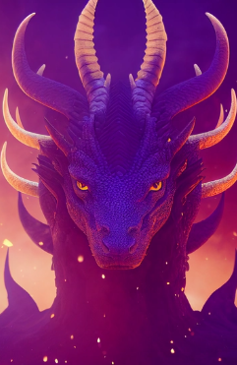

Anthropomorphic majestic falcon knight, falcon portrait, finely detailed egyptian armor, egyptian design, cinematic lighting, intricate filigree metal design, 4k, 8k, unreal engine, octane render,

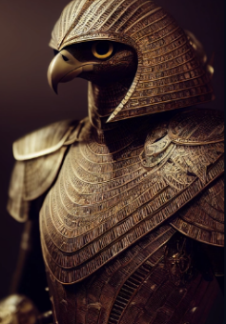

werewolf wearing purple armor, realistic eyes, character portrait, octane render,

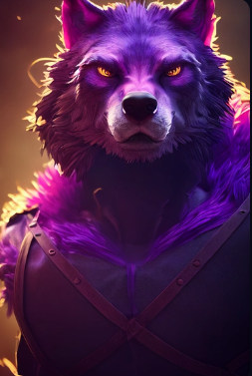

Anthropomorphic majestic Re, falcon head portrait, finely detailed black armor, cinematic lighting, intricate filigree metal design, 8k, unreal engine, octane render, realistic, volumetric lighting,

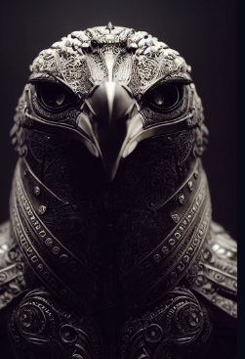

Anthropomorphic majestic lion knight, portrait, finely detailed armor, fantasy character concept, pure, benevolent, strong, portrait, line art, realistic, hyper-maximalist, intricate details, epic composition, golden ratio, CryEngine render, marquee lighting, 8k, photo realistic, stunning, detailed, fantasy, magic circle, illusion, aura, sacred, fractal, cinematic lighting, intricate filigree metal design, 4k, 8k, unreal engine, octane render, volumetric

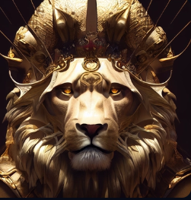

Healing, cute,Multi-red cat in jacket with sunglass, ultra detailed, 8k, cinematic, full-frame portrait composition, Animation,

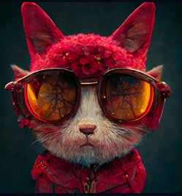

anthropomorphic bird cowboy

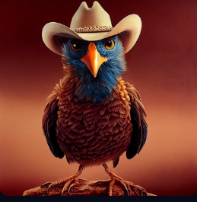

Anthropomorphic samoyeds dog knight, portrait, finely detailed armor,Gold, crystal， portrait,cinematic lighting, intricate filigree metal design, 4k, 8k, unreal engine, octane render,

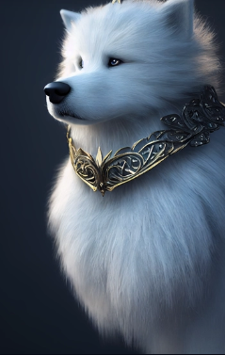

Tiny cute and adorable baby fox, symmetrical ears and eyes, jean-baptiste monge, anthropomorphic, Delight winter and snow backgrounds, elegant shapes, magical dreamy lighting, wallpaper, photorealistic, Rembrandt light, fantasy, detailed, symbolic, high detailed, 3d render, 8k

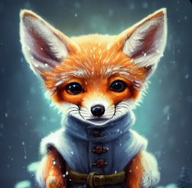

ixar Style, anthropomorphic, Tiny cute and adorable Pedington the bear Hobbit adventurer dressed in fantasy traditional clothes hanfu standing in the surreal small twilight Xingkong rose garden, trending on artstation, Gorgeous

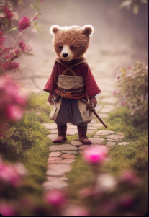

Anthropomorphic owl wearing a graudation outfit, 8k, photorealisitc

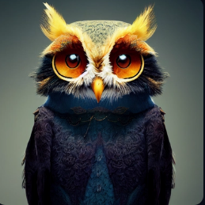

Pixar Style, Tiny cute and adorable bunny tiger dressed in a tennis outfit holding a tennis racket playing tennis, jean-baptiste monge, anthropomorphic,dramatic lighting,8k, portrait,realistic,fine details, photorealism,cinematic,intricate details, cinematic lighting, photo realistic 8k

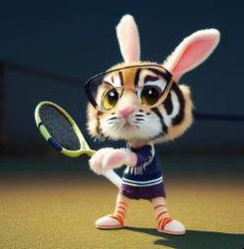

an anthropomorphic cat wearing samurai armor, cyberpunk, intricate design, robot, hyperrealistic, cinematic lighting, photorealistic, volumetric lighting, unreal engine,

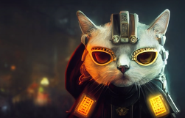

Tiny cute adorable fluffy white cat with knitted blue scarf leaning at a table in a medieval pub holding a coffee cup, anthropomorphic, Jean-Baptiste Monge, soft cinematic lighting, 8k, intricate details, portrait, Pixar style character, old fashioned movie style

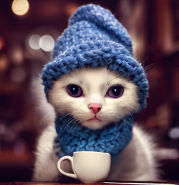

an adorable Pixar style butter monster character chasing corn, anthropomorphic, skinny arms, Royal outfits, octane tender, voluminous lighting, ultra realistic, photorealistic, octane render, unreal engine

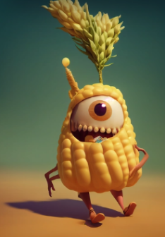

anthro, anthropomorphic, black wolf, fluffy lime-green mohawk, vertical lime-green stripe markings under eyes, red pupils, light grey nose, focused expression, red eyes, vray render, 8k, 4k, maroon bandana on neck, contemplative, character design, punk, industrial bar piercing in ear,

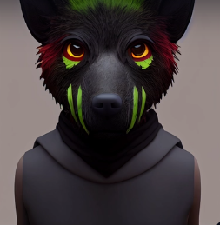

anthropomorphic crane wearing cyberpunk armor, high detail, portrait, intricate

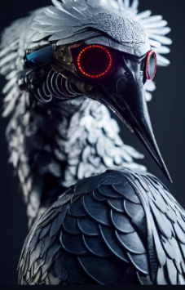

punk rock anthropomorphic wolf with lots of piercings, 8k, unreal 5 rendering, detailed background, dynamic pose, anime inspired

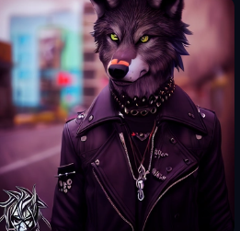

Anthropomorphic majestic lion knight, portrait, finely detailed armor, fantasy character concept, pure, benevolent, strong, portrait, line art, realistic, hyper-maximalist, intricate details, epic composition, golden ratio, CryEngine render, marquee lighting, 8k, photo realistic, stunning, detailed, fantasy, magic circle, illusion, aura, sacred, fractal, cinematic lighting, intricate filigree metal design, 4k, 8k, unreal engine, octane render, volumetric

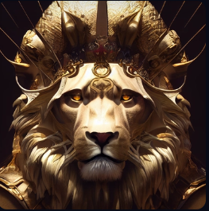

a cyberpunk anthropomorphic alpaca in noir suit, alpaca has sunglasses, alpaca is evil and smiling, intricate details, cinematic lighting, volumetric lighting, 4k, 8k, hyper realistic, unreal engine, octane render, smooth render, no noise

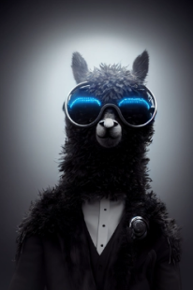

anthropomorphic rat knight, warrior, paladin, mouse, steel, iron, weapon, very detailed, hyper realistic,

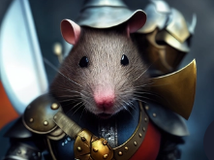

anthropomorphic river otter, blonde hair, green eyes, commanding pose

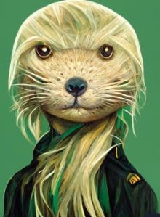

Tiny cute adorable fluffy baby raccoon with knitted blue scarf leaning at a table in a medieval pub holding a coffee cup, anthropomorphic, Jean-Baptiste Monge, soft cinematic lighting, 8k, intricate details, portrait, Pixar style character, old fashioned movie style

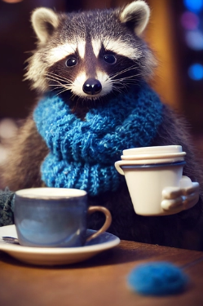

Anthropomorphic wolf, portrait, steampunk, borg implants, finely detailed armor, cinematic lighting, intricate filigree metal design, 4k, 8k, unreal engine, octane render,

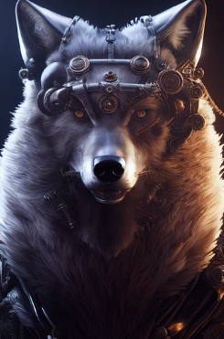

furry anthropomorphic humanoid wolf cyberpunk symmetrical detailed

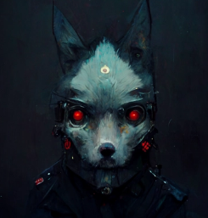

formal portrait of anthropomorphized seal wearing black aviator glasses and an earpiece, photo realistic, well lit

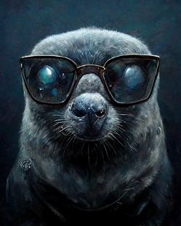

< anthropomorphic cute fox knight character, holding a sword

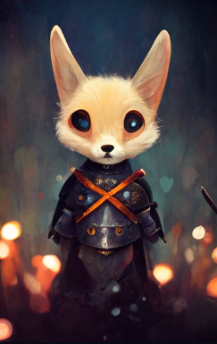

cobra snake. Camouflage uniform. Portrait. 8k. Anthropomorphic

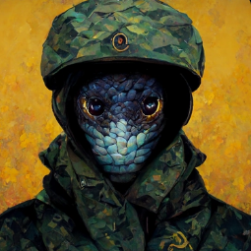

crow person magician, a kenku druid, anthropomorphic crow, advernturer, DnD

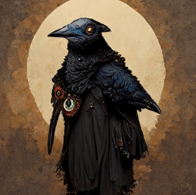

a marble statue of a peacock

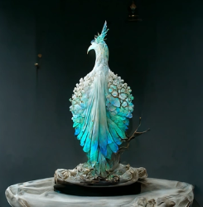

kneeling cat knight, portrait, finely detailed armor, intricate design, silver, silk, cinematic lighting, 4k,

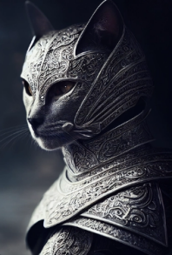

kneeling cat knight, portrait, finely detailed armor, intricate design, silver, silk, cinematic lighting, 4k,

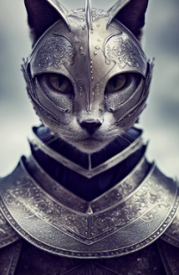

nyan dragon, divine, epic, cat-dragon, crystal crown, biomech, dark, ivory, scales, wide angle, portrait, symmetrical

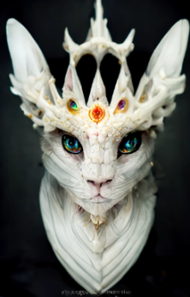

Anthropomorphic majestic eagle knight, portrait, finely detailed armor, cinematic lighting, intricate filigree metal design, 4k, 8k, unreal engine, octane render

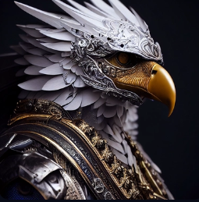

warrior rabbit, cute, disney pixar, highly detailed, concept art, portrait

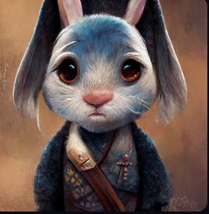

portrait, Anthropomorphic elephant knight, elegent detailed armor, cinematic lighting, intricate filigree metal design, octane render,

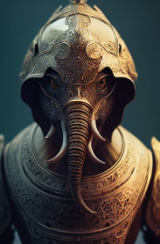

portrait photography of anthropomorphic-hippo wearing disco-suit

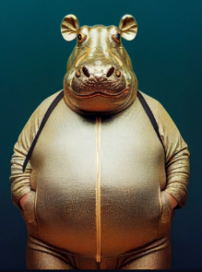

anthropomorphic majestic wolf knight, portrait, finely detailed armor, intricate filigree metal design, brass, silk, cinematic lighting, 4k, 8k, unreal engine, octane render,

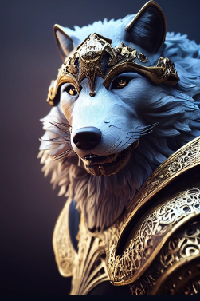

anthropomorphic majestic cat knight, portrait, finely detailed armor, intricate filigree metal design, brass, silk, cinematic lighting, 4k, 8k, unreal engine, octane render,

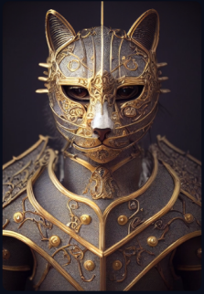

Pixar Style, Tiny cute and adorable fall rat adventurer dressed in hoodie, jean - baptiste monge , anthropomorphic , dramatic lighting, 8k, portrait,

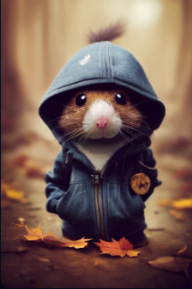

Anthropomorphic majestic panther knight, portrait, finely detailed armor, cinematic lighting, intricate filigree metal design, 4k, 8k, unreal engine, octane render,

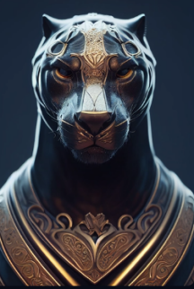

epic 3d portrait of white King Kong wearing mech armor made of black crystals, golden ornate around the armor, symmetrical body, hyperrealistic, intricate details, shiny, cinematic, unreal engine, artstation, octane render,

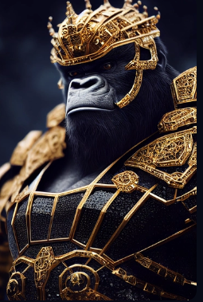

Tiny cute adorable mouse dressed as a king in a castle, anthropomorphic, Jean-Baptiste Monge, soft cinematic lighting, 8k, intricate details, portrait, Pixar style character, old fashioned movie style

